刘骜宇：

* Team slide

1. Your name: Aoyu Liu
2. Your roles: Frontend Designer

* Project scope

1. Brief description of current & future work (What to do)

* Basic design and realization of the frontend website.
* Able to interact with backend and the users.
* Implement the project on the web server.

1. How to complete related work (How to do)

* AJAX
* Dreamweaver
* Django
* IIS

1. Brief description of the problems encountered (Project constraint: limitations of time, people and costs that you must operate within)

* Time limitation.
* Not familiar with the implementation.

曾昕玥

**Roles :**

the people creates database and change types of data

**The results we have and how we manage it:**

Research:

we choose to analyze the data with the bank evaluation criteria:

The changes of data:

Photo1:

From the codes below, we change excel data into database:

The selection of data:

Photo 2:

Then we consider divide the data types into 6 parts:

Problem statement:

Technologies: Python, MySQL, financial knowlodege.

**The results we will have and how we will manage it in the future:**

A database with clear division:

By the knowledge of database and MYSQL, we will achieve a relational database.

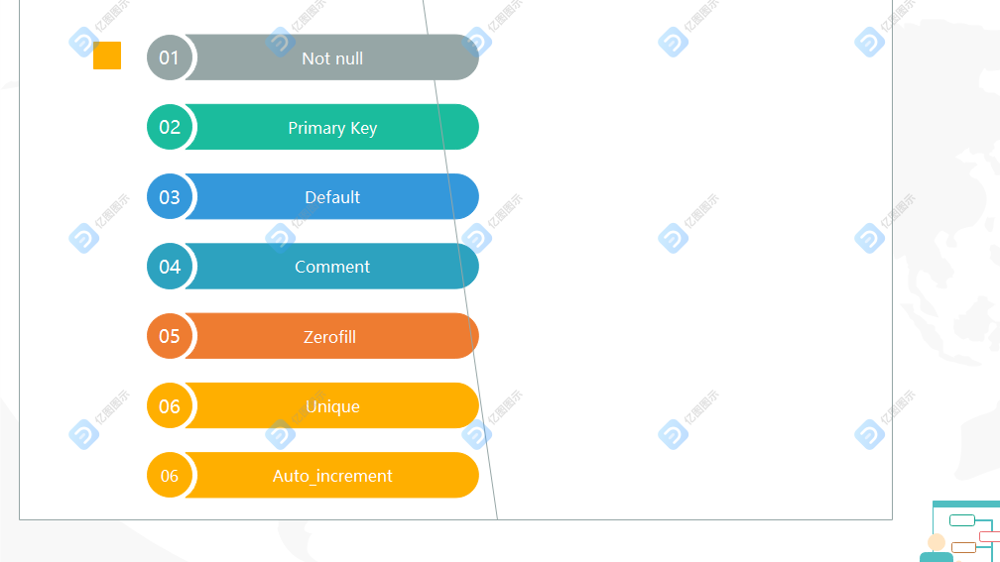

The changes of datatype:

Iwrite is an example.

Problems until now:

Considering 7 rules of database, the formats of data is still a question.

The division of database still needs to improve.

The safety of database may cause loss of companies.



常慧茹

■ Team slide

1.Your name: Huiru Chang

2.Your roles: Front-end

Project scope

1.Brief description of current & future work (What to do)

▪Current work: web design

▪Future work: Simple web front end implementation, financial material modeling

2.How to complete related work (How to do)

▪ Analyze the feasibility of web page implementation

▪ Obtaining effective information from financial materials

3.Brief description of the problems encountered (Project constraint: limitations of time, people and costs that you must operate within)

▪ Modeling of financial analysis

Solution: Using keywords to extract